Nama : Amaliyah Gian F

NIM : 18090085

Kelas : 5A

Praktikum 1

1. Source Codes

Perkenalan.php -> apllication/controller

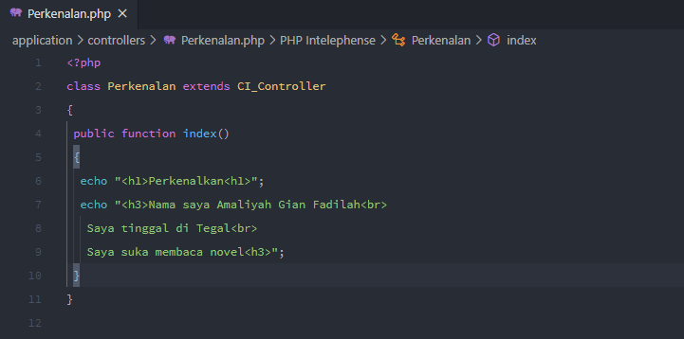

1. Hasil URL

[http://localhost//pustaka-booking/index.php/perkenalan/](http://localhost//pustaka-booking/index.php/Perkenalan/%20)

1. Capture Hasil

